After Create Case:

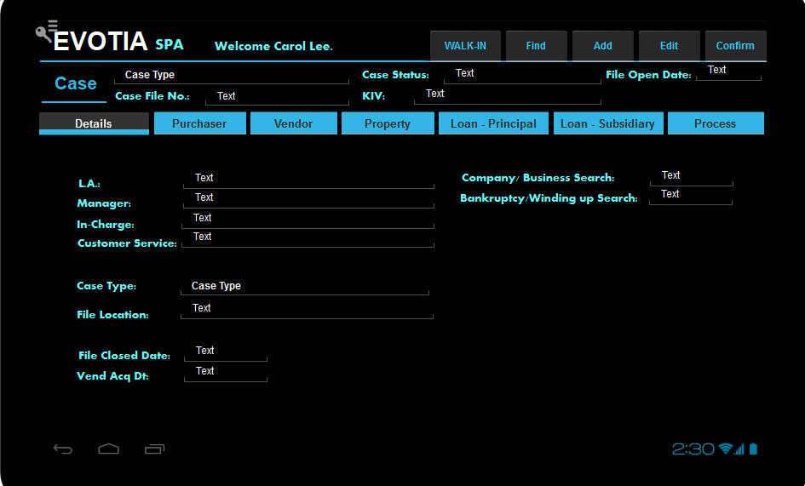

Back End in SAP, populate the case with Related Party and User information.

Case header:

Case status is a drop down with “Open/Closed”. (View SAP valid values)

KIV is a drop down. (View SAP valid values)

If user is LA, allow user to choose. All other users can only view.

When case is first created, Case status is always “Open”.

If user change Case status from Open to Close and click confirm, prompt “Confirm Close Case? Yes / No”.

If user choose yes, check if the case can be closed.

Validation:

No sales quotation lines except item code 999999 has U_Status = “Pending”.

All item codes in the sales quotation have at least 1 “Accept” in U_Status.

Example 1:

|  |  |
| --- | --- |
| Item A | ACCEPT |
| Item A | FAIL |
| Item B | ACCEPT |

Can close case.

Example 2:

|  |  |
| --- | --- |
| Item A | FAIL |
| Item A | FAIL |
| Item B | ACCEPT |

Cannot close case.

Example 3:

|  |  |
| --- | --- |
| Item A | ACCEPT |
| Item A | FAIL |
| Item B | PENDING |

Cannot close case.

When user click Yes to confirm close case and the case can close, update file close date to current date. Update ocrd.inactive = “Y”. Update inactive remarks as Case Closed by < The Name of the LA” who closed the case.

Update to the case:

* the customer service: CS/IC user’s emp ID and Name who created the case
* the in-charge: IC user’s emp id and Name who assigned to the case
* the manager: MG supervising the IC
* the LA: LA supervising the IC
* Case Type:
  + if Question 1 = SELL then case type = SPA-SS-V
  + if Question 1 = BUY, Question 2 = SUBSALES, then case type = SPA-SS-P
  + if Question 1 = BUY, Question 2 = DEVELOPER,  
    Question 4 = UC, then case type = SPA-DD-P-RUC
  + if Question 1 = BUY, Question 2 = DEVELOPER,  
    Question 4 = COMPLETED, then case type = SPA-DD-P-RCCom
  + if Question 1 = BUY, Question 2 = DEVELOPER,  
    and ACT FOR DEVELOPER (IN QUESTION 2 SCREEN) IS TICKED,  
    then case type = SPA-DD-V

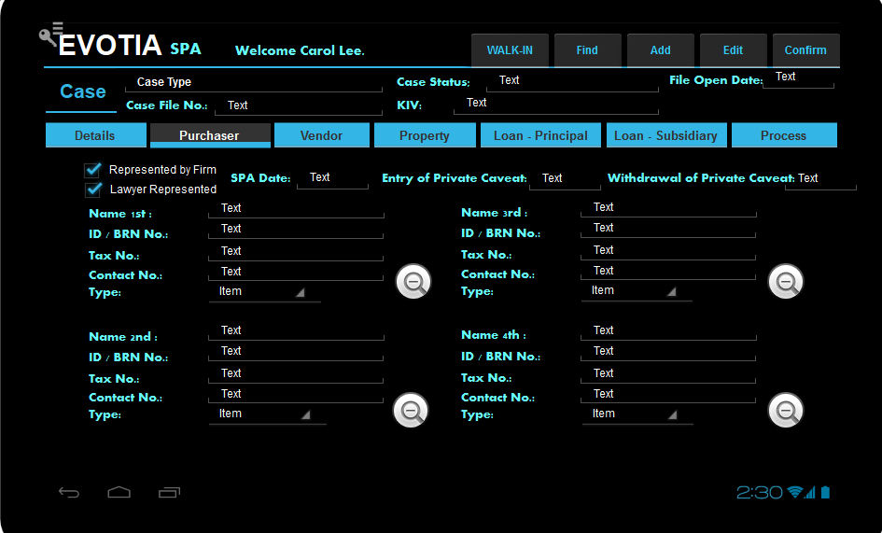

This screen should reflect the information captured from the SAP after the purchaser has been added to the screen.

If “Represented by Firm” is ticked, “Lawyer represented” is always ticked as well.

These 2 fields must be read only, cannot amend.

If you click the zoom button, you should see the individual screen as per the view individual screen with the IC scan or the view corporate screen.

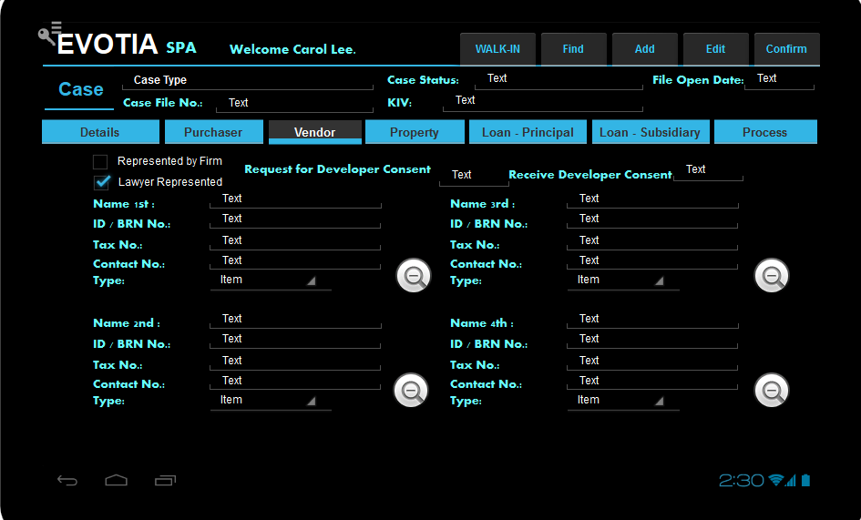

This screen should reflect the information captured from the SAP after the purchaser has been added to the screen.

If “Represented by Firm” is ticked, “Lawyer represented” is always ticked as well.

These 2 fields must be read only, cannot amend.

If you click the zoom button, you should see the individual screen as per the view individual screen with the IC scan or the view corporate screen.

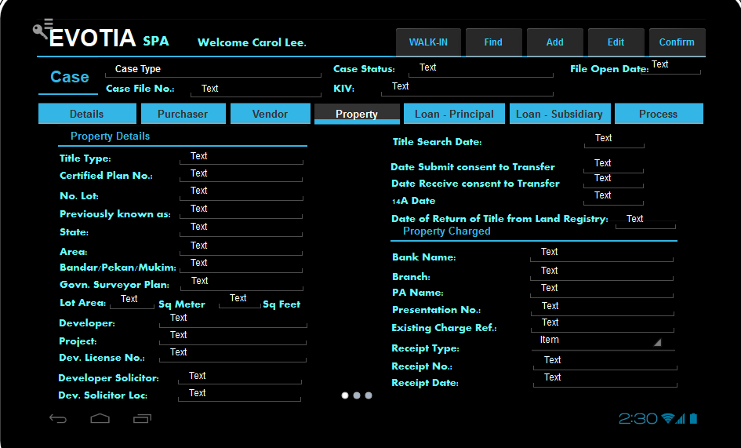

Should show the information from the case creation.

If user amend property information, it should update the property UDO as well.

Add a tick box to the right of “PROPERTY CHARGED” HEADER.

If user tick the box, update the OCRD.QryGroup13 ”PROPERTY CHARGED” = “Y” property field.

Add drop down list below title type, name is Title Sub-Type.

Values are Individual Title / Strata Title / Master Title.

If Individual Title is selected, set OCRD.QryGroup14 ”PROPERTY CHARGED” = “Y”

If Strata Title is selected, set OCRD.QryGroup15 ”PROPERTY CHARGED” = “Y”

If Master Title is selected, set OCRD.QryGroup16 ”PROPERTY CHARGED” = “Y”

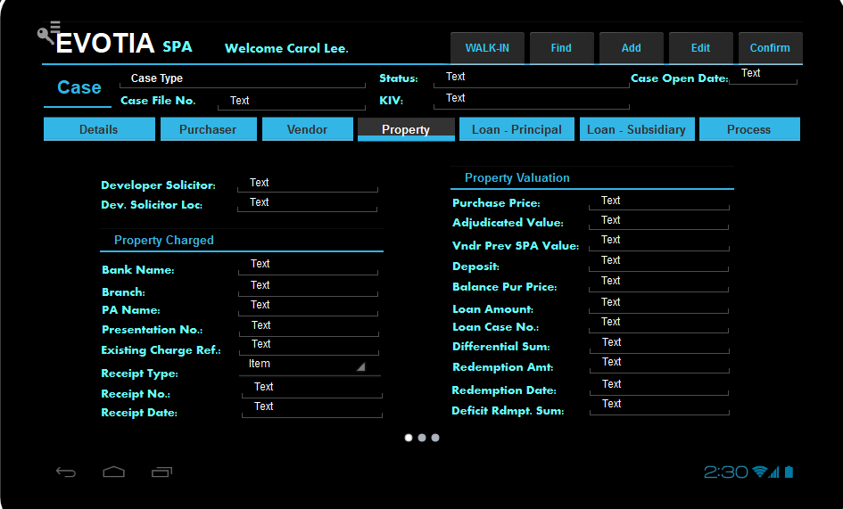

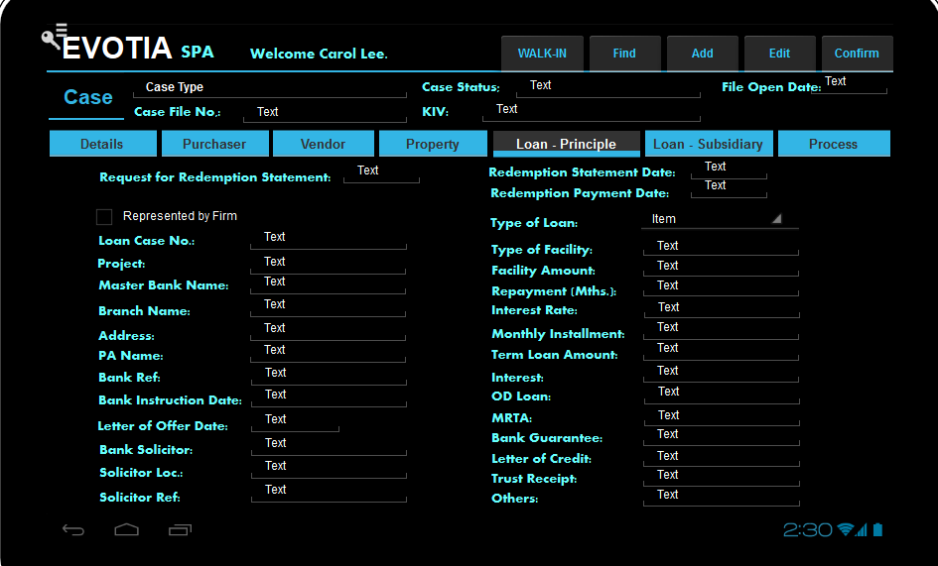

All the fields are editable fields. Update the case with Last update by User Name, the save the update date and time. Ensure this is in audit log.

**PROCESS CASE**

* When a case is generated, a sales quotation is created.
* The process screen is separated into “PAST SECTION”, “OPEN SECTION”, “NEW SECTION”.
* When user clicks the “PROCESS” tab, by default it will show the “OPEN SECTION”.
* When the case is first created, there are no past sections, so “PAST SECTION” button is dimmed off.
* A step is an item in the sales quotation.
* “PAST SECTION” contains steps processed and closed.
* “OPEN SECTION” contains steps open sales quotation lines.
* “NEW SECTION” is an action button to create new sales quotation lines after the “OPEN SECTION” is closed.

In both “PAST SECTION” and “OPEN SECTION”, sales quotation lines are created and sorted in the view by QUT1.U_INT_CASE_SEQ.

Both “PAST SECTION” and “OPEN SECTION” will not show items with QUT1.U_INT_CASE_SEQ = 999999999.

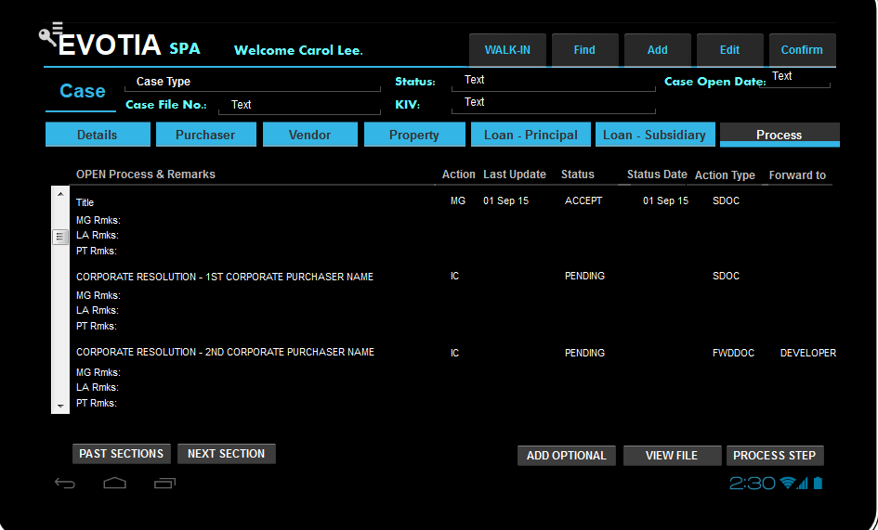

**USER CLICKS “PAST SECTION”**

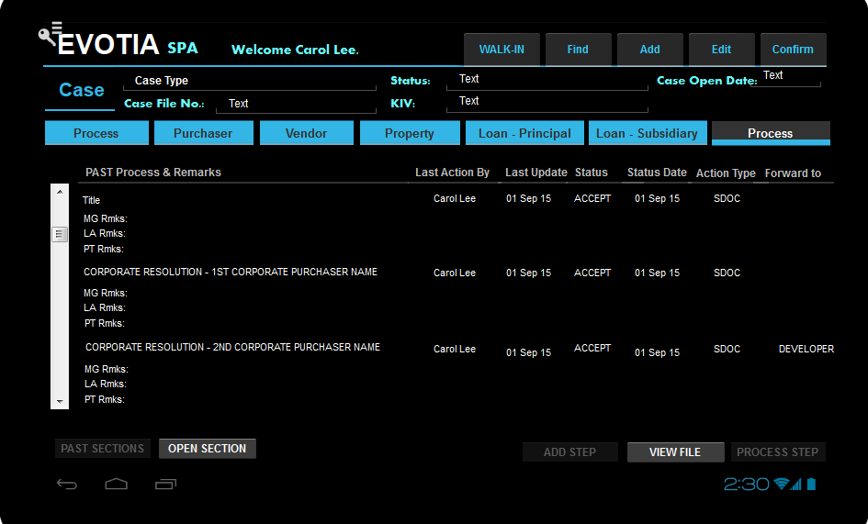

* After user click “PAST SECTIONS” button, it will bring the user to the list of closed sales quotation lines.
* User can view, cannot amend.
* User chooses a line item and click “VIEW FILE”.
* If the “QUT1.U_RESULTS_FILE” is not null, show the pdf file.
* If user clicks “OPEN SECTION”, it will bring the user to the open sales quotation lines screen.

**USER CLICKS OPEN SECTION**



User is brought back to “OPEN SECTION”.

**USER CLICKS “NEXT SECTION”**

Check for every open qut1.line_status with the same item code except the one with int_case_seq = 999999999, there must exists at least 1 quotation line with ACCEPT.

If the condition is true, close all open sales quotation lines except the one with int_case_seq = 999999999.

Create new sales quotation lines for the next section.

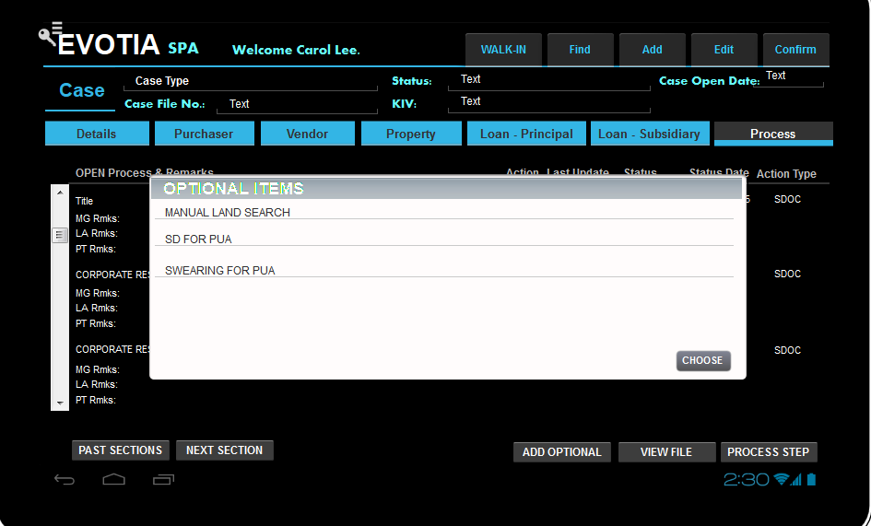

**USER CLICKS “ADD OPTIONAL” BUTTON**

In the Pop Up screen, it shows all the items with blank oitm.U_int_case_seq and the item properties match the users’ selection. User chooses the additional item and this item is added as a new sales quotation line item, set Qut1.U_int_case_seq = the open section int_case_seq code.

**USER CLICKS “PROCESS STEP” BUTTON**

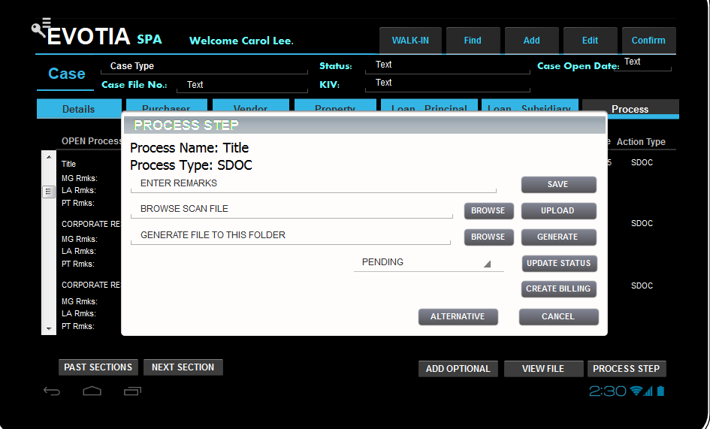

**Process name = qut1.dscription**

**Process type = oitm.shiptype**

Only if user’s role is the same as the “Action” field, user can click “CREATE BILLING” button.

If user’s role is either “MG”, “LA” or “PT”, the user can enter remarks and click save.

The remarks can be saved to the respective column.

If user’s role the same as the sales quotation line action, user can perform the following tasks base on the item action type table below:

|  |  |  |
| --- | --- | --- |
| Oitm.shiptype  Action type | SAP Document Creation | SAP Action by & Status Update |
| ADD-PO-D | When user click “Create Billing”,   * Create Sales Order with case. * Update Sales Quotation Number and Line into Sales Order. * Update Cost center 1 with OCRD.U_Branch_Code * Update Cost Center 2 with OCRD.U_LOAN_MSTR_BANKCODE * Update item price by calling the function: getFee() * Document date, Posting Date and Due Date are current date * Create Back to back Purchase Order with item default supplier. Item price is the same as Sales Order Price. * Copy the Back to back Purchase Order to AP Invoice | When IC click “Create Billing”, change Action by to “Finance”.  Status is “Pending”  After Finance make outgoing payment and close the AP invoice, change Action by to “Dispatch”.  Status is “Pending”.  After IC click Upload file, change Action by to “IC”.  Status is “Pending”.  Call Gopi’s Program to validate the file with the item code.  If success, change Status to “ACCEPT”.  If fail, change Status to “FAIL”.  Change Action by to “MG” or “LA” depending on the item setup. |
| ADD-PO | When user click “Create Billing”,   * Create Sales Order with case. * Update Sales Quotation Number and Line into Sales Order. * Update Cost center 1 with OCRD.U_Branch_Code * Update Cost Center 2 with OCRD.U_LOAN_MSTR_BANKCODE * Update item price by calling the function: getFee() * Document date, Posting Date and Due Date are current date * Create Back to back Purchase Order with item default supplier. Item price is the same as Sales Order Price.   Copy the Back to back Purchase Order to AP Invoice | When IC click “Create Billing”, change Action by to “Finance”.  Status is “Pending”  After Finance make outgoing payment and close the AP invoice, change Action by to “IC”.  Status is “Pending”.  After IC click Upload file, change Action by to “IC”.  Status is “Pending”.  Call Gopi’s Program to validate the file with the item code.  If success, change Status to “ACCEPT”.  If fail, change Status to “FAIL”.  Change Action by to “MG” or “LA” depending on the item setup. |
| GDOC | User clicks “Generate” Button.  Call GOPI’S program to generate PDF document. | Change the status to “ACCEPT” |
| SDOC | User clicks “Upload” Button.  Call GOPI’S program to read and verify the document. | If Gopi’s program checks and verify document. If success, change status to “ACCEPT”.  If fail, change status to “FAIL”.  User can rescan 5 times. If “Fail” on the 6th time, change ACTION BY to “MG” or “LA” depending on the item setup. |
| OPDOC | User clicks “Upload” Button. | Change the status to “ACCEPT” |
| TDOC | User clicks “Upload” Button.  Call GOPI’S program to read and verify the document. | If Gopi’s program checks and verify document. If success, change status to “ACCEPT”.  If fail, change status to “FAIL”. |
| FWDOC | User change the status from “PENDING” TO “ACCEPT” |  |
| MANUAL-FIN | User change the status from “PENDING” TO “ACCEPT” |  |
| MANUAL-FIN-C | User change the status from “PENDING” TO “ACCEPT” |  |
| MANUAL-IC | User change the status from “PENDING” TO “ACCEPT” |  |
| FEES | User clicks “CREATE BILLING”   * Create Sales Order with case. * Update Sales Quotation Number and Line into Sales Order. * Update Cost center 1 with OCRD.U_Branch_Code * Update Cost Center 2 with OCRD.U_LOAN_MSTR_BANKCODE * Update item price by calling the function: getFee()   Document date, Posting Date and Due Date are current date | When user clicks “CREATE BILLING”.  Update STATUS to “ACCEPT”. |
|  |  |  |

**For all action types, check the oitm.U_UPDATE_CASE_DATE field. If it is not blank, update the corresponding field indicated in this field with the date the status changed to “ACCEPT”.**